Here are some graphics on RJ (Registered Jack) Insert Pin-outs that you will most definitely come in contact with every day in telco.

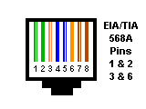  10 BASE T  RJ45 EIA/TIA 568A | 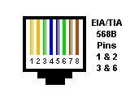  10 BASE T  RJ45 EIA/TIA 568B | It is worth noting here that what is commonly referred to as a RJ45 is really wired to the RJ61C Standard.  Don't get hung up on it. RJ45 is fine!  The RJ designation depends on how the Insert is wired.
Note: No matter whether a punch-down is EIA TIA 568A or 568B - 10 Base T is on the same pins - only the color code is different. So remember - for a working network link to be established:
568A to 568A
568B to 568B

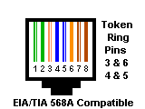 | 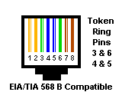 | 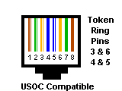
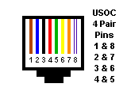  USOC RJ48C | 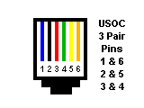  USOC RJ25 | 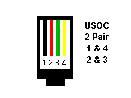  USOC RJ14
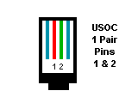  USOC RJ11 | 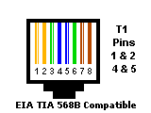  USOC RJ48X  T1/DS1/DSX | 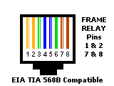  USOC RJ48S  FRAME RELAY

